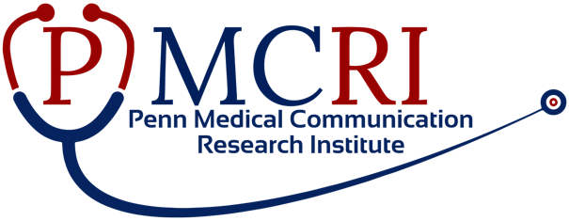
Penn Medical Communication Research Institute Pilot Award Program
The Penn Medical Communication Research Institute will fund up to three (3) one-year multidisciplinary pilot grants of $50,000 each. Proposals must center on communication of medical information, with priority given to studies with experimental designs. Each proposal must have at least two faculty Co‐Principal Investigators from different disciplines within the University of Pennsylvania. Instructors are eligible to apply. Novel collaborative applications between faculty located in distinct schools in Penn are encouraged.
Potential topics include, but are not limited to, the following:
- The flow of scientific information through medical journals.
- The impact of preprint servers and dissemination of non-peer reviewed information on patient care
- How to improve public trust in the scientific process
  - Communication of errors and retractions
  - Norms of self-correction and the value of replication and transparency
- How to reduce deception and bias in reporting
- How to optimize the use of technology to provide content to medical providers
2. The flow of medical information through traditional journalism
- The accuracy of press releases in representing study validity and conclusions
- The effect of the content of a press release on its dissemination
- Sources of medical information used by journalists
- The flow of medical information to the public.
- Assessment of how patients obtain medical content and variation by region of the country, literacy, cultural content, and access to technology
- Methods to improve dissemination and uptake of medical information to a diverse audience
- Methods to direct internet searches and social media toward scientifically accurate medical information
- Strategies to help clinicians respond to patient’s misperceptions that are guided by misinformation

Please also see lectures from previous symposia and a description of previous pilot award projects: https://www.med.upenn.edu/pmcri/request-for-abstracts.html

Important Dates:
Initial phase: Project title, faculty names with affiliations, and 250 word abstract emailed to Enjoli Barnes at Enjoli.Barnes@pennmedicine.upenn.edu by 5 pm, November 18, 2022.
Second phase: Submission of a 2-page application with biosketches and a budget will be requested in a subset, for submission by December 16, 2022.
Award Start date: February 1, 2023

